Department Home Page: hr.kennesaw.edu
Department Email Address: hr@kennesaw.edu

Main Phone Line: 470-578-6030
Fax: 470-578-9174
Your Phone Line: 470-578-XXXX
Your NetID:

Coworker Name | Title | Email | Phone
Employee A | Direct Supervisor
Employee B | Team Member
Employee C | Team Member
Employee D | Team Member
Employee E | Team Member
Employee F | Team Member

Physical Address: 3391 Town Point Drive
Suite #2000
Kennesaw, GA 30144

Mailing Address: 1000 Chastain Road, MD 9120
Kennesaw, GA 30144

Billing Address: Kennesaw State University
Human Resources
3391 Town Point Drive
Suite #2000
Kennesaw, GA 30144
Mission Statement

Human Resources is dedicated to collaborating with institutional leaders to maximize the potential of KSU employees, our greatest asset. We are focused on delivering quality services required to recruit, develop, and retain a talented and engaged workforce.
Vision Statement

We collaborate with our campus partners to provide leading HR services that attract, develop, and retain employees in order to deliver an exceptional campus experience where everyone can thrive.

View / Download the 2022-2024 HR Roadmap

Departmental Org Chart (download here)

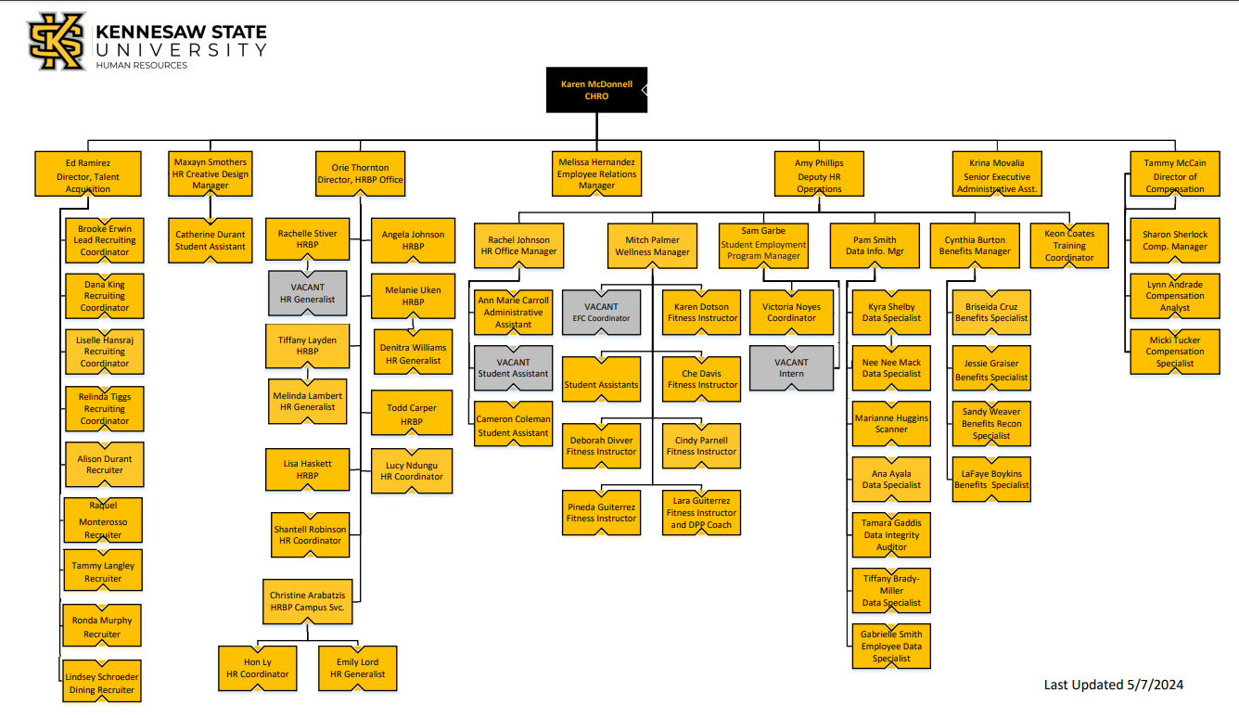
Employee Training Schedule

Your manager will provide you with an onboarding schedule for your first two weeks.

Asset Tracking
Your (Supervisor or Departmental Representative) will assign equipment, keys/key cards, system access, gear, etc. as appropriate

Position Description

A copy of your position description is attached. Your supervisor will review it with you.
Email Groups/List Servs
You will be added to the following email groups and list servs.
- hrstaff@kennesaw.edu
- DEPARTMENT resource accounts as discussed
Calendars
You will be granted access to the following calendars and/or we encourage you to add the following calendars to your list.
- HR Calendar – all telework and time off days should be recorded here

OwlPal

Name/title will be your buddy.

The purpose of being assigned a buddy is to provide you with a casual, reliable, single point-of-contact for your basic questions regarding our department.
Expectations of your OwlPal are to:
- Serve as a casual resource to answer routine questions regarding basic operational issues, department practices, and department culture. Some examples may include:
  - Where the bathrooms are located
  - Good places to eat for lunch
  - Parking tips
  - How to get around the building
- Build on the knowledge you obtained in New Employee Orientation and department orientation
- Help make introductions
- Respect confidentiality
- Follow up with you on a regular basis during the first few months
Your OwlPal will NOT serve as a mentor and is not responsible for your job performances. If questions arise regarding performance or policy matters, your buddy may give their opinion and advice on how to approach the situation, however, is not in a position to resolve the matter. You should reach out to your manager for resolution of relevant issues.
Your buddy will expect you to:
- Display an eagerness to learn
- Display a coachable attitude
- Receive constructive criticism in good spirit

Policies and Regulations

Kennesaw State University Policy, Rules, and Regulations
policies.kennesaw.edu

USG Employees
University System of Georgia Website: www.usg.edu

Work Periods and Time Away from Work

Work Schedules

Scheduling is the responsibility of the manager. The department must maintain coverage during the business hours of 8:00 a.m. and 5:00 p.m.

Adverse Weather

In the event of unfavorable/unsafe weather conditions the university functions under the Adverse Weather Policy. Employees should notify their supervisor if they are unable to make it into the office.

Reporting Absences

Employees who are unable to be at work must notify their supervisor by phone prior to their starting time.

*Note: supervisors should specify the best method for notification. For example, some supervisors may prefer to be notified via work email of the absence and reason for absence.

Leave Usage

USG offers multiple types of leave. Employees can go to the Human Resources Administrative Practice Manual (HRAP) site and refer to the Time Away from Work section for more information on the types of leave and accrual rates.

Employees should submit requests for leave to their supervisor for prior approval via OneUSG and post on the HR shared calendar. Leave usage includes sick leave, vacation leave, Educational Support leave.

Requests to use sick leave are to be submitted to supervisors in instances that include personal illness; illness of an immediate family member; medical appointments of an employee or employee’s immediate family member and death in an employee’s immediate family. Requests to use sick leave should be finalized through OneUSG immediately upon return to work.

Please contact the Benefits Manager for any sick leave absence more than 5 missed workdays.

Lunch Periods (remove for FLSA exempt employees)

Every full-time FLSA Subject/ Non-exempt employee is entitled to a one-hour lunch period that is to be taken at the appropriate time as designated by the work unit supervisor. Extended or shortened lunch periods (30 minutes minimum) must be approved by the supervisor.

Time-Keeping (remove for FLSA exempt employees)

Federal law (Fair Labor Standards Act/FLSA) requires that time records be maintained for employees subject to FLSA. Hourly (non-exempt) employees must track hours in OneUSG.

Therefore, hourly employees must use OneUSG to track actual time worked for each day and reflect vacation, sick, holidays and other leave when applicable.

“Exempt” employees (those who are not subject to FLSA) are not required to track actual time worked but will use OneUSG to track leave time used.

Please refer to the KSU Human Resources website for details on OneUSG

Overtime (remove for FLSA exempt employees)

KSU abides by the FLSA policy for hourly/non-exempt employees. Overtime must have supervisory approval beforehand.

Equipment Usage and Safety

Email Usage

The University email system should be used for university business. Message exchanges are considered public record. They are auto archived, and become part of the permanent system files that can be retrieved at a later date even if deleted from your personal files/folders.

The signature line of your email should be set up at https://emailsignature.kennesaw.edu/login.php

Calendar Usage

Employees are required to use their university assigned Outlook electronic calendar. This will allow others to view time blocked from your calendar and will allow individuals to schedule meetings around your available time.

Telephone/Fax Usage

Telephones and fax machines are to be used for conducting University business; personal calls should be made with discretion.

- To call locally and long distance, dial entire phone number (area code/phone number).
- On campus, dial 4-digit extension (last four of entire on campus phone number)
- To call international, country code + city + phone number + number.

Computer Usage

Employees must comply with the University’s Computer Usage regulation found at:

https://uits.kennesaw.edu/ocs/policy/directory.php

Employee Resources

Employee Assistance Program (EAP)
An EAP is professional help when you need it in your work or personal life. It's trained knowledgeable resources to provide advice for the many life issues we all face. As a KSU employee, you and your family have the benefit of a customized assistance program which offers professional counseling and consultation through Accentra.

Tuition Assistance Program

The Tuition Assistance Program (TAP) allows eligible employees to attend classes at any USG institution under a waiver of tuition and most fees. An employee may seek approval to enroll in up to nine (9) academic credit hours per semester
TAP APPLICATION PORTAL

For more Employee Resources visit https://www.kennesaw.edu/human-resources/resources/employees/index.php

